**1-4 Assignment: Users and Solutions**

Harvey Corey

CS-360-18509-M01 Mobile Architect & Programming 2024 C-6 (Oct - Dec)

Professor Alex Benavente

Nov 10, 2024

My app of choice is Discord mobile since I use it a lot. The purpose of the app is to allow the user to send messages, pictures, and videos live to other users in real time and connect to communities. It also promotes communities that others can join and create discussions with. You can also load up games to play in calls with these communities as well. It has a lot of utilities specifically geared for social features.

The needs that need to be addressed would be simple at the lowest level. Messaging and communication is at the very least, something Discord does very well. Another utility is the ability to send messages. It’s easier and faster to send messages through Discord than via traditional texting. Voice calls is another minimum requirement, it’s also something that Discord does very well. In a voice call, you can share your screen, camera feed, play games, or play sounds from a soundboard. This app serves users who want to connect with friends, or a community in a social way. Discord supports all of this by giving the user tools to socialize. The most persuasion the app may do is in app purchasing. The app has a business objective of creating a large social network and then selling cosmetics or a subscription to those who are interested.

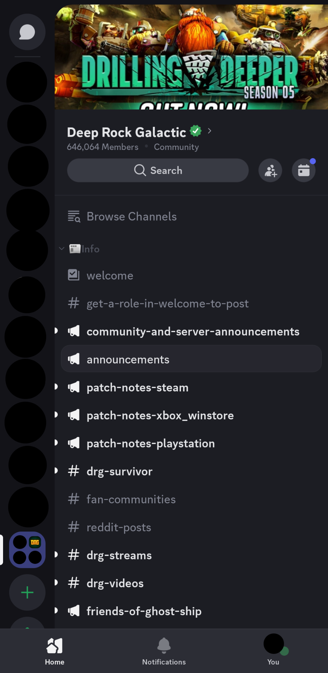

Personal information has been censored, sorry.

The features of the app are tailored to meet user’s needs by adding quick navigation with the bar to the left. The black circles represent each community and the highlighted element at the bottom is a folder you can put all your server shortcuts in. The navigation for the mobile app has been notoriously bad in the past, but I see no issues now, or I’ve gotten used to the design. The buttons in my opinion are clear and show exactly what the user needs to know. The only thing that I don’t like is the direct messages button. It feels hidden at the top left of the screen.

The smaller details go into a folder-like structure akin to Window’s file explorer. This makes everything categorized in a very organized fashion. The direct messages button brings up all information on direct messages, including adding/removing new friends for more/less direct messages.

One of the things Discord does really well is demographics. It has a whole database of servers that it can check. The creators of Discord also fall into the same demographic as well. Essentially, they are making an app for themselves too. I would implement a feedback tool and website to gain insight on what users think of the aspects of the app. This already exists, however. There is a website where you can recommend ideas, get them voted for and give feedback or report bugs. If I were responsible for designing this app, I’d already have all the information I would need from all the demographic research Discord already has.